**Digital Nurture 4.0 Deep Skilling - Java FSE**  
**WEEK –6 Additional Hands-on Exercises**  
**Module 10 - React**

**6. ReactJS-HOL**

**Solution:**

**Code:**

**Trainer.js**  
class Trainer {

constructor(TrainerId, Name, Email, Phone, Technology, Skills) {

this.TrainerId = TrainerId;

this.Name = Name;

this.Email = Email;

this.Phone = Phone;

this.Technology = Technology;

this.Skills = Skills;

}

}

export default Trainer;

**TrainerDetails.js**

import React from 'react';

import { useParams } from 'react-router-dom';

import trainers from './TrainersMock';

function TrainerDetail() {

const { id } = useParams();

const trainer = trainers.find(t => t.TrainerId.toString() === id);

if (!trainer) return <div>Trainer not found.</div>;

return (

<div>

<h2>Trainer Details</h2>

<p><b>ID:</b> {trainer.TrainerId}</p>

<p><b>Name:</b> {trainer.Name}</p>

<p><b>Email:</b> {trainer.Email}</p>

<p><b>Phone:</b> {trainer.Phone}</p>

<p><b>Technology:</b> {trainer.Technology}</p>

<p><b>Skills:</b> {trainer.Skills.join(', ')}</p>

</div>

);

}

export default TrainerDetail;

**About.js**

import React from 'react';

function About() {

return (

<div>

<h2>Welcome to the About page of the Student Management Portal</h2>

</div>

);

}

export default About;

**TrainerList.js**

import React from 'react';

import { Link } from 'react-router-dom';

function TrainersList({ trainers }) {

return (

<div>

<h2>Trainers List</h2>

<ul>

{trainers.map(trainer => (

<li key={trainer.TrainerId}>

<Link to={/trainers/${trainer.TrainerId}}>{trainer.Name}</Link>

</li>

))}

</ul>

</div>

);

}

export default TrainersList;

**Trainersmock.js**

import Trainer from './Trainer';

const trainers = [

new Trainer(101, "Alice", "alice@mail.com", "123-456-7890", "React", ["React", "JavaScript"]),

new Trainer(102, "Bob", "bob@mail.com", "222-456-7891", "Java", ["Java", "Spring"]),

];

export default trainers;

**App.js**

import React from 'react';

import { BrowserRouter, Routes, Route, Link } from 'react-router-dom';

import Home from './Home';

import trainers from './TrainersMock';

import TrainersList from './TrainerList';

import TrainerDetail from './TrainerDetails';

function App() {

return (

<BrowserRouter>

<div>

<nav style={{ marginBottom: "1em" }}>

<Link to="/" style={{ marginRight: 15 }}>Home</Link>

<Link to="/trainers">Trainers List</Link>

</nav>

<Routes>

<Route path="/" element={<Home />} />

<Route path="/trainers" element={<TrainersList trainers={trainers} />} />

<Route path="/trainers/:id" element={<TrainerDetail />} />

</Routes>

</div>

</BrowserRouter>

);

}

export default App;

**Output:**

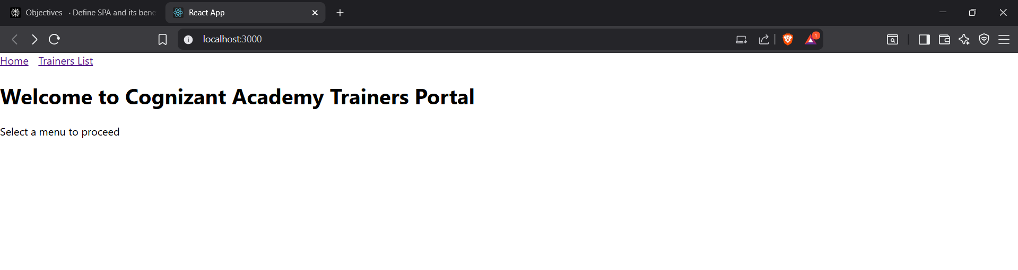

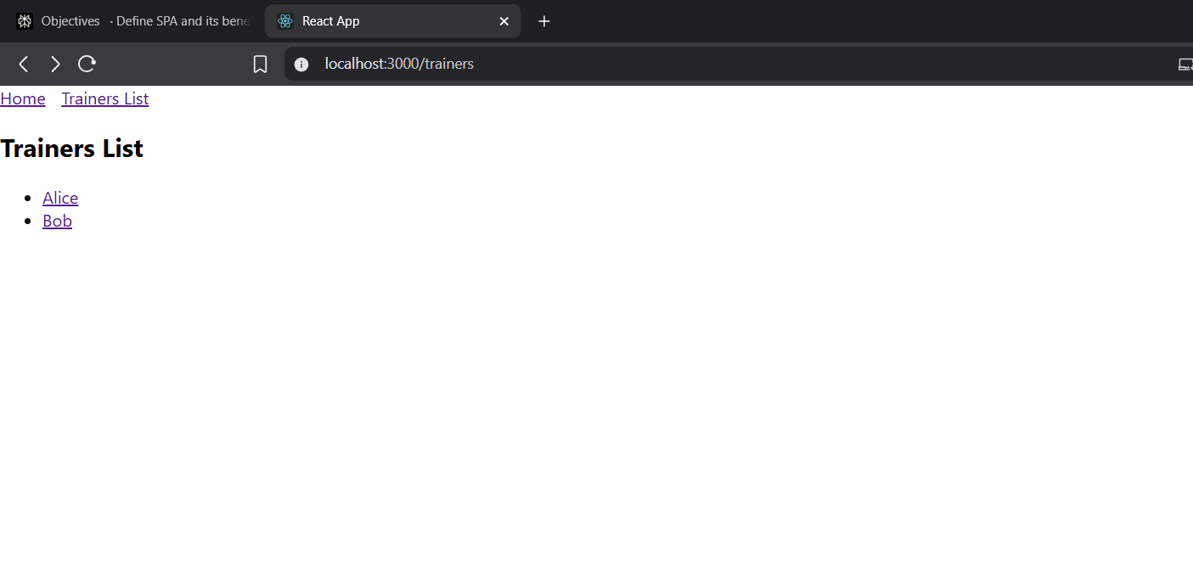

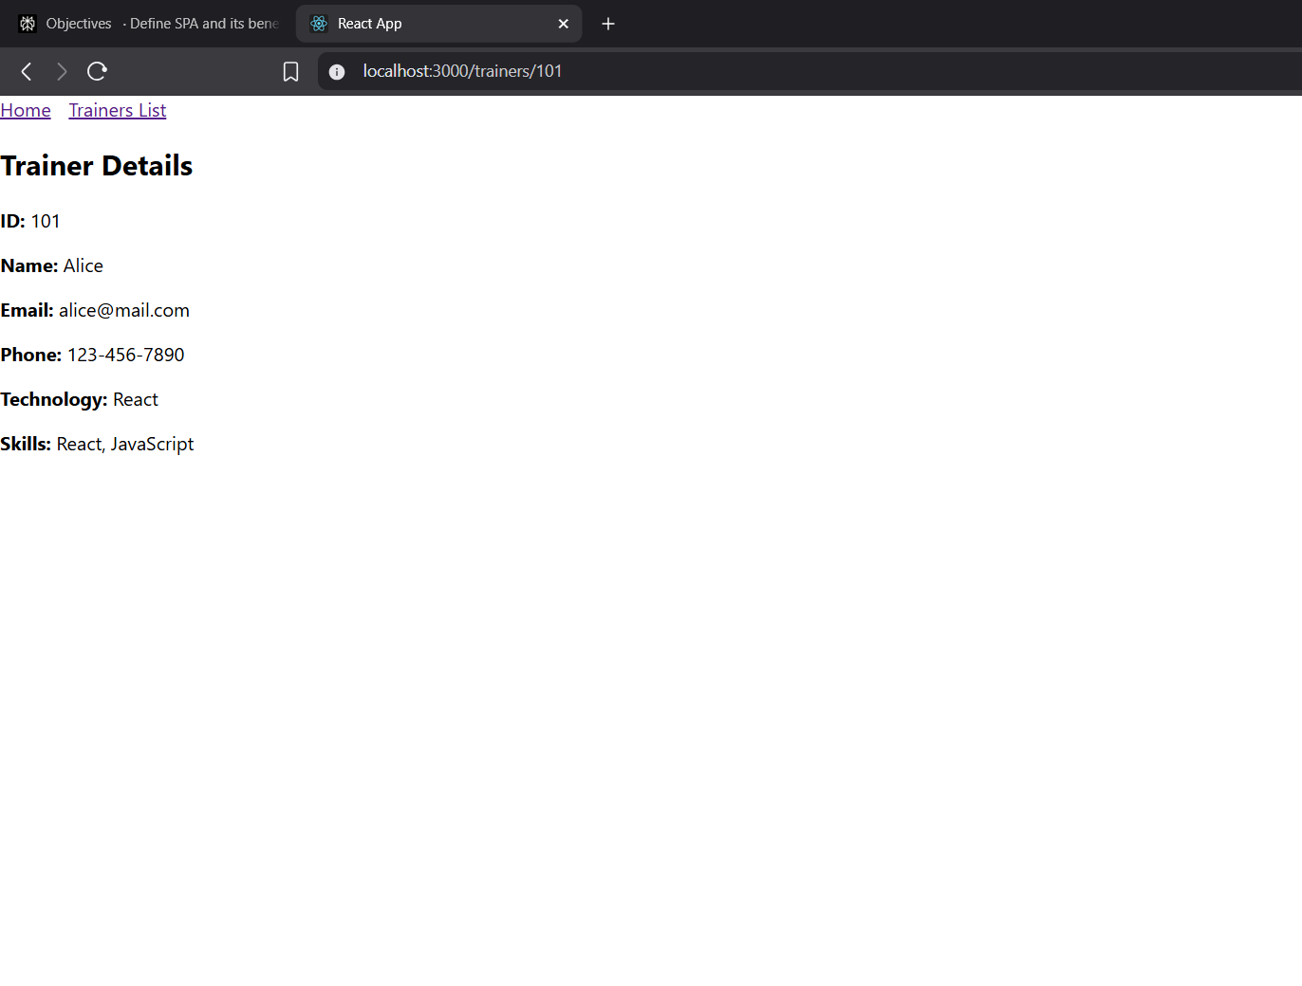

**7. ReactJS-HOL**

**Solution:**

**Code:**

**Cart.js**

class Cart {

constructor(itemName, price) {

this.ItemName = itemName;

this.Price = price;

}

}

export default Cart;

**mystyle.css**

import React from 'react';

class CartComponent extends React.Component {

render() {

const { itemName, price } = this.props; // props passed from parent

return (

<div style={{ marginBottom: '10px', border: '1px solid gray', padding: '10px', width: '300px' }}>

<h3>Item: {itemName}</h3>

<p>Price: ${price}</p>

</div>

);

}

}

CartComponent.defaultProps = {

itemName: 'Unknown Item',

price: 0,

};

export default CartComponent;

**OnlineShopping.js**

import React from 'react';

import Cart from './Cart';

import './mystyle.css';

class OnlineShopping extends React.Component {

constructor(props) {

super(props);

this.cartItems = [

new Cart('Laptop', 80000),

new Cart('TV', 120000),

new Cart('Washing Machine', 50000),

new Cart('Mobile', 30000),

new Cart('Fridge', 70000)

];

}

render() {

return (

<div className="centered-container">

<h1 className="item-heading">Items Ordered :</h1>

<table className="styled-table">

<thead>

<tr>

<th>Name</th>

<th>Price</th>

</tr>

</thead>

<tbody>

{this.cartItems.map((item, idx) => (

<tr key={idx}>

<td>{item.ItemName}</td>

<td>{item.Price}</td>

</tr>

))}

</tbody>

</table>

</div>

);

}

}

export default OnlineShopping;

**App.js**

import React from 'react';

import OnlineShopping from './OnlineShopping';

function App() {

return <OnlineShopping />;

}

export default App;

**Output:**

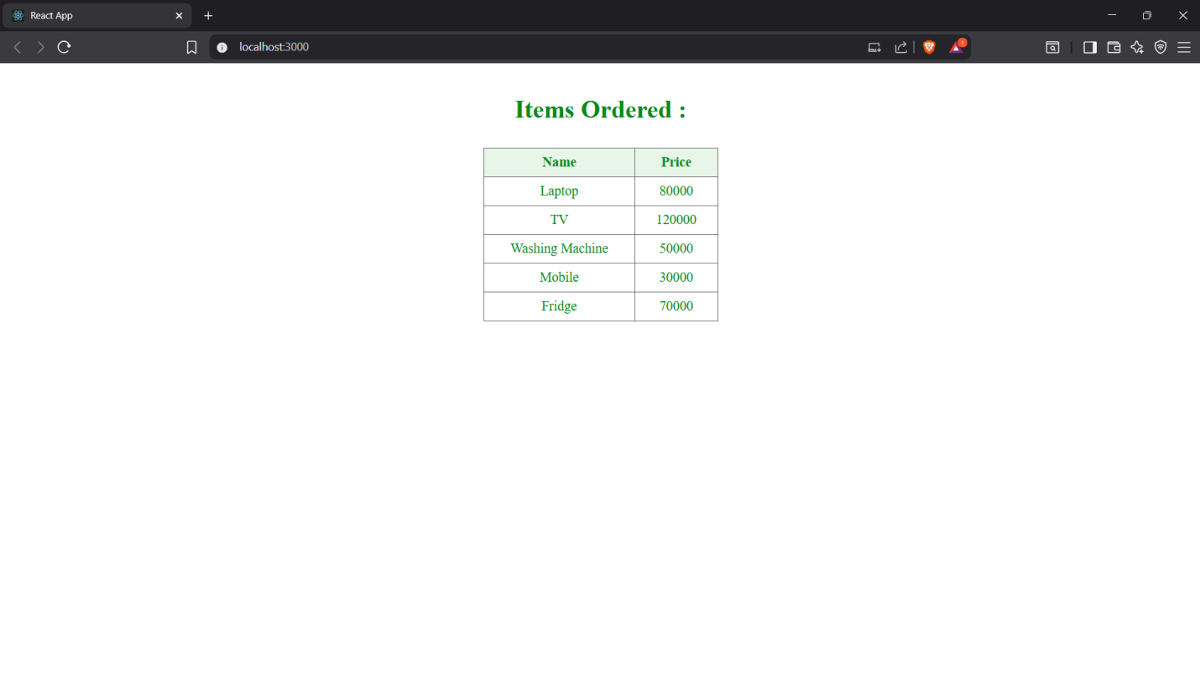

**8. ReactJS-HOL**

**Solution:**

**Code:**

**CountPeople.js**  
import React, { Component } from 'react';

class CountPeople extends Component {

constructor(props) {

super(props);

this.state = {

entrycount: 0,

exitcount: 0,

};

}

UpdateEntry = () => {

this.setState((prevState) => ({

entrycount: prevState.entrycount + 1,

}));

};

UpdateExit = () => {

this.setState((prevState) => ({

exitcount: prevState.exitcount + 1,

}));

};

render() {

return (

<div style={styles.container}>

<h1 style={{ marginBottom: 30 }}>Mall Counter</h1>

<div style={styles.countDisplay}>

<div style={styles.countBox}>

<h2>People Entered</h2>

<p style={styles.countNumber}>{this.state.entrycount}</p>

</div>

<div style={styles.countBox}>

<h2>People Exited</h2>

<p style={styles.countNumber}>{this.state.exitcount}</p>

</div>

</div>

<div style={styles.buttonContainer}>

<button style={styles.button} onClick={this.UpdateEntry}>

Login

</button>

<button style={styles.button} onClick={this.UpdateExit}>

Exit

</button>

</div>

</div>

);

}

}

const styles = {

container: {

textAlign: 'center',

marginTop: 80,

fontFamily: 'Arial, sans-serif',

},

countDisplay: {

display: 'flex',

justifyContent: 'center',

marginBottom: 40,

},

countBox: {

border: '2px solid #4caf50',

borderRadius: '10px',

padding: '20px 40px',

margin: '0 20px',

backgroundColor: '#e8f5e9',

minWidth: '150px',

},

countNumber: {

fontSize: '2.5rem',

fontWeight: 'bold',

marginTop: 0,

},

buttonContainer: {

display: 'flex',

justifyContent: 'center',

},

button: {

backgroundColor: '#4caf50',

color: 'white',

fontSize: '1.2rem',

padding: '12px 30px',

margin: '0 15px',

border: 'none',

borderRadius: '8px',

cursor: 'pointer',

transition: 'background-color 0.3s',

},

};

export default CountPeople;

**App.js**

import React from 'react';

import CountPeople from './CountPeople';

function App() {

return (

<div>

<CountPeople />

</div>

);

}

export default App;

**Output:**

